Quarterly Board of Directors Meeting
Wednesday, June 21, 2023 – 9:00 a.m.
USF Center for Advanced Medical Learning Simulation (CAMLS)
124 S. Franklin St., Tampa FL 33602

Mission: Strategically and innovatively address the issues of nursing supply and demand to meet the needs of the people of Florida by:
- Developing and implementing strategies, building evidence to support best practices, and providing recommendations for systemic changes;
- Generating and disseminating credible information to the public, professional organizations, healthcare providers, educational institutions, and legislators;
- Encouraging and coordinating the development of academic-practice partnerships; and
- Identifying and promoting recognition, reward, and licensure renewal activities for nurses and future nurses.
Vision: The Florida Center for Nursing is the definitive source for information, research, and strategies addressing the dynamic workforce needs of nursing in Florida.
Values: Responsibility, Integrity, Inclusivity, Transparency, Bravery

AGENDA
Call to Order and Roll Call | 9:00 a.m. to 9:05 a.m.
Welcome & Introductions
Review statutory changes for new year | 9:05 a.m. to 9:15 a.m.
Review appointments | 9:15 a.m. to 9:30 a.m.
Board allowance and per diem
FCN Bylaws  - Determine co-chair  - Establish finance committee  - Establish research committee | 9:30 a.m. to 10:30 a.m.
Break | 10:30 a.m. to 10:45 a.m.
Strategic Planning | 10:45 a.m. to 12:00 p.m.
Lunch (on your own) | 12:00 p.m. to 1:00 p.m.
Performance Appraisal of FCN Executive Director (executive session) | 1:00 p.m. to 2:30 p.m.
Presentation from the CareerSource Florida, Ms. Susan Bosse | 2:30 p.m. to 3:30 p.m.
Break | 3:30 p.m. to 3:45 p.m.
Social Media Policy | 3:45 p.m. to 3:50 p.m.
FCN quarterly impact report | 3:50 p.m. to 4:15 p.m.
Other Matters | 4:15 p.m. to 5:00 p.m.
Upcoming Meetings
- June 2023
- September 2023
- December 2023
- March 2024
- June 2024
Adjourn

Local food options:
- On site – Café on first floor of CAMLS offering a fully stocked fridge of “grab and go” items
- Off-site- under a 10-minute walk from CAMLS
  - Breakfast- Starbucks, Caffé Fresco & Marketplace, The Corner Cafe & Deli
  - Lunch/Dinner- Hattricks, Harpoon Harry’s Crab House, The Pint & Brew

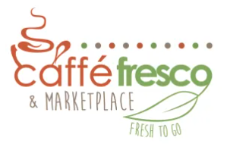  https://www.caffefrescotampa.com/ | 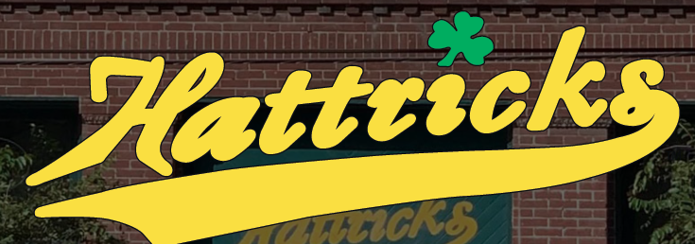  https://hattrickstavern.com/
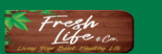  https://freshlifeandcompany.com/ | 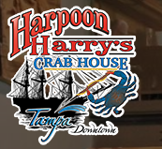  https://www.harpoonharryscrabhousetampa.com/
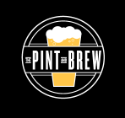
https://www.thepintandbrew.com/

